ASSIGNMENT 4

180919

* **Try to build, run, and understand the app**

The application displays the most recent public pictures that’s uploaded to the Flickr website. It retrieves data from the flickr website using http requests then displays the results in a GridLayout RecyclerView.

* **Search and understand how various websites use REST web API**

REST is used to build Web services that are lightweight, maintainable, and scalable in nature. The underlying protocol for REST is HTTP, which is the basic web protocol.  REST is a way to access resources which lie in a particular environment. If a client (web browser) needs any resources ( for example documents, videos, pictures, etc) it has to send a request to the server to access these resources.  When the client makes any request to this web service, it can specify any of the normal HTTP verbs of GET, POST, DELETE and PUT.

* **Design an app retrieving tasks info from your Flask web service, realize the core functions in sequence:**

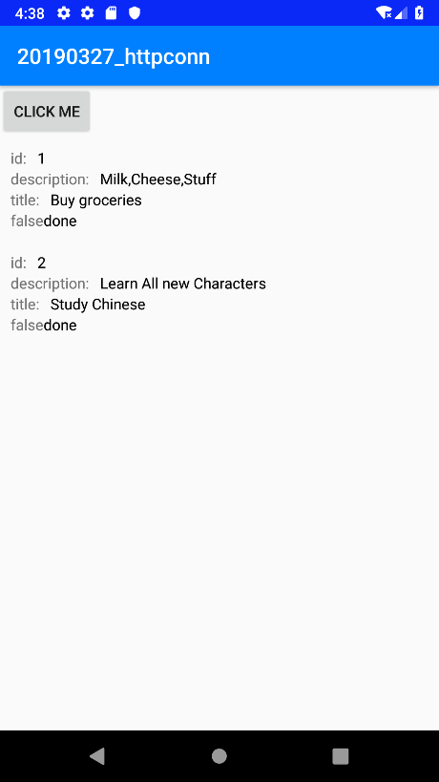

* **HTTP connection to get JSON data**

The code below creates the HTTP connection then collects the json data.

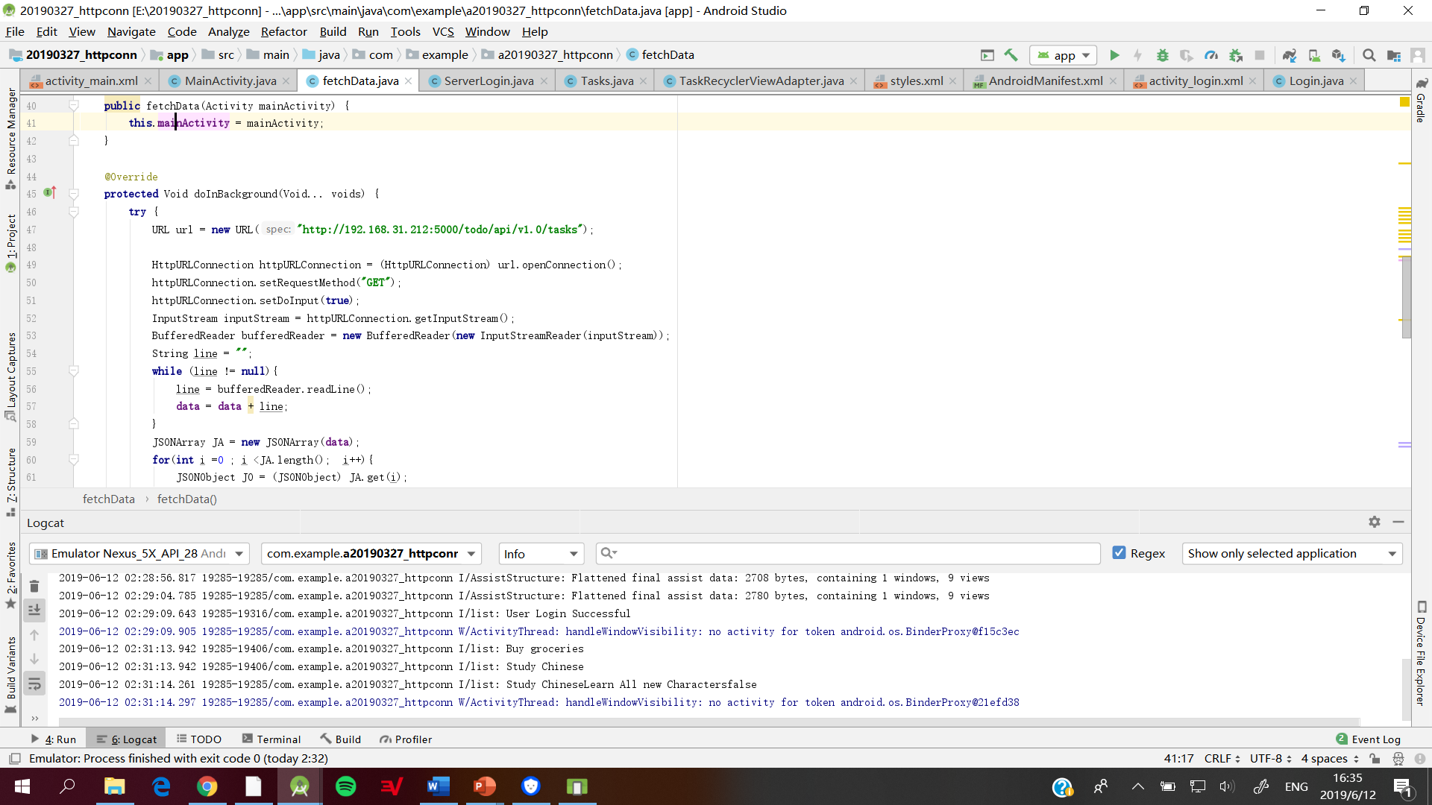

* **Deserialize JSON data to object structure**

The JSON data that is retrieved from the server is then stored in a JSON Array then those values are then converted into a JSON of object. The values are then retrieved from the JSON Object.

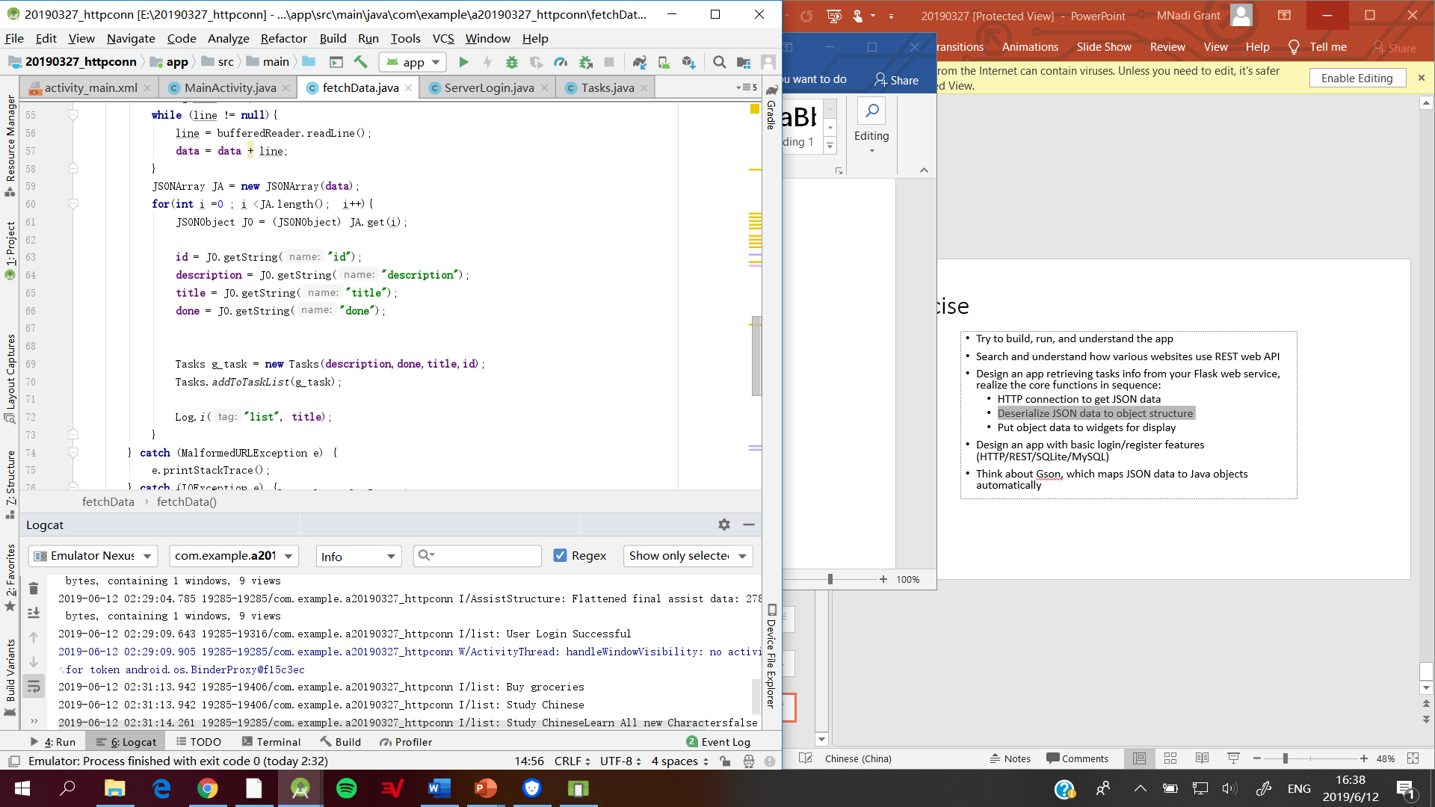

* **Put object data to widgets for display**

The data is displayed in a recycler view. After all the json object values are retrieved it is then converted into a Task Object then added to an array list. The items in the array list are then displayed in a recyclerview.

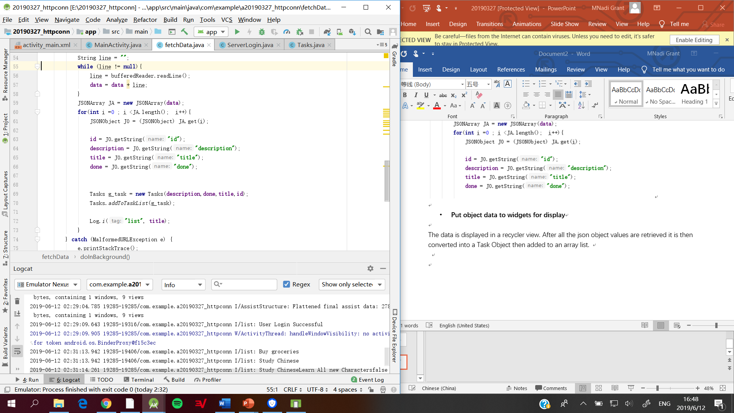

* **Design an app with basic login/register features (HTTP/REST/SQLite/MySQL)**

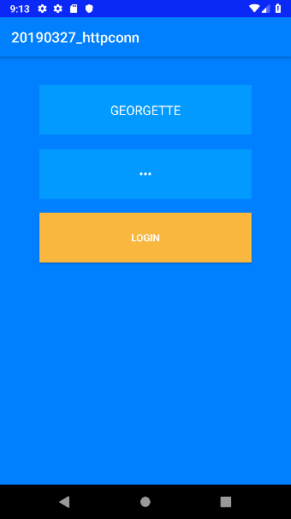

This application uses HTTP/REST. The server contains a list of users. A method was created in flask to fetch the user with the same User name and Password. If there is a match, the server will display a message saying “User Login Successful”.

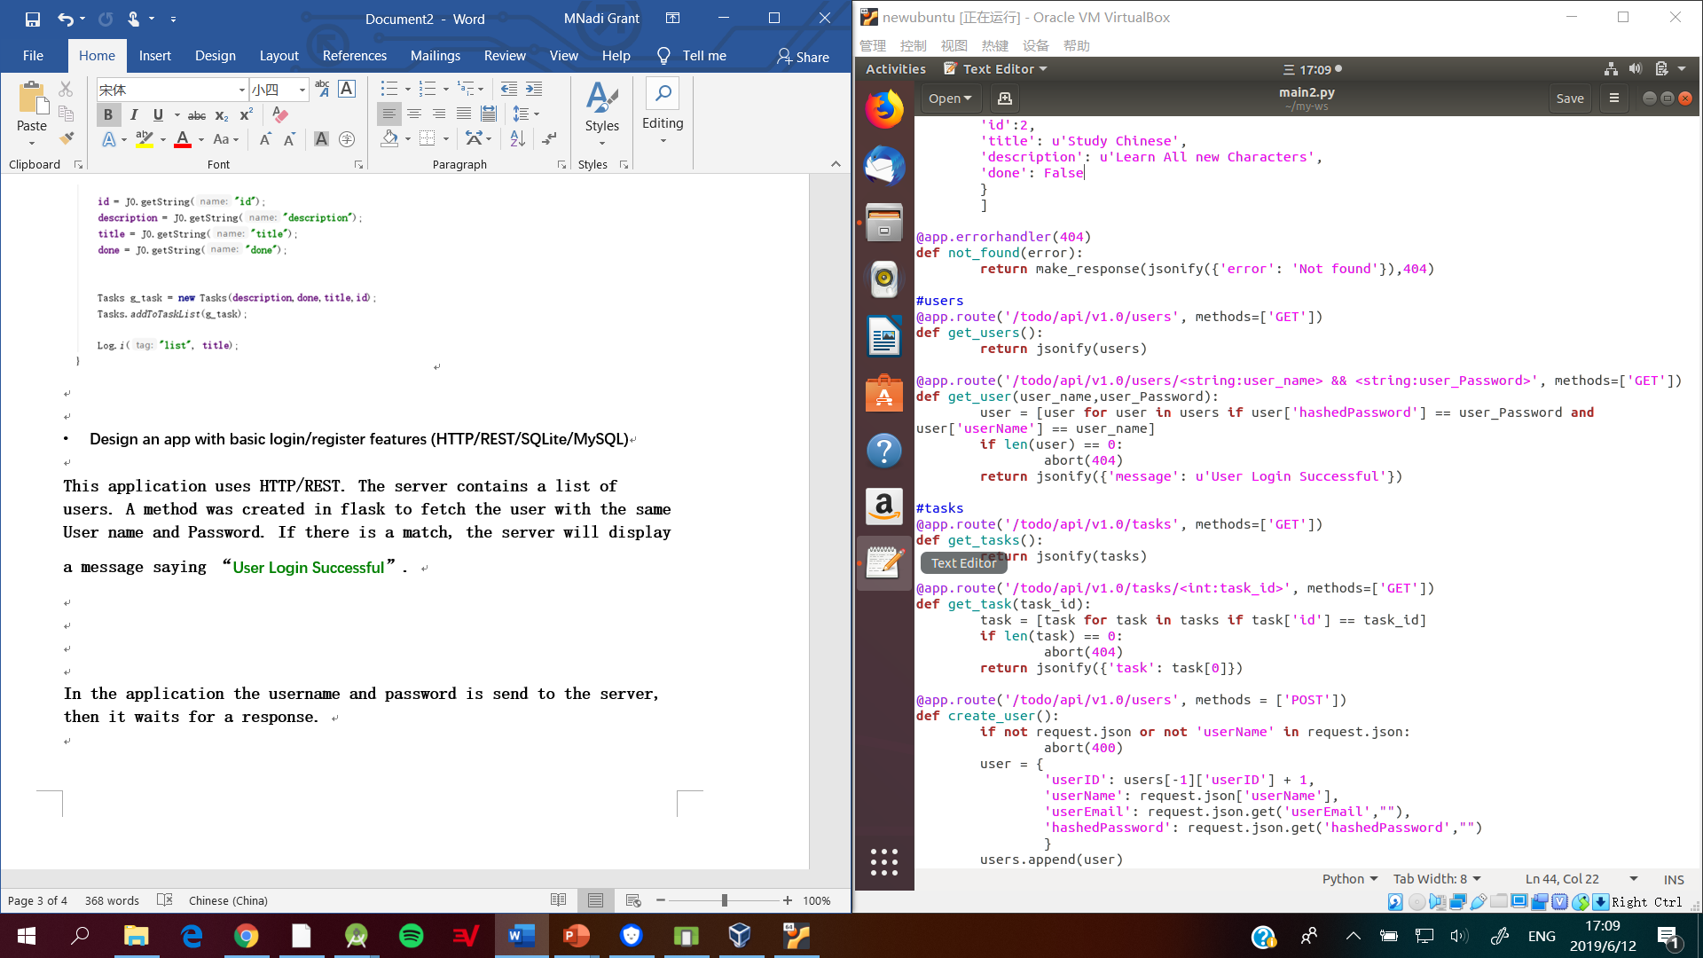

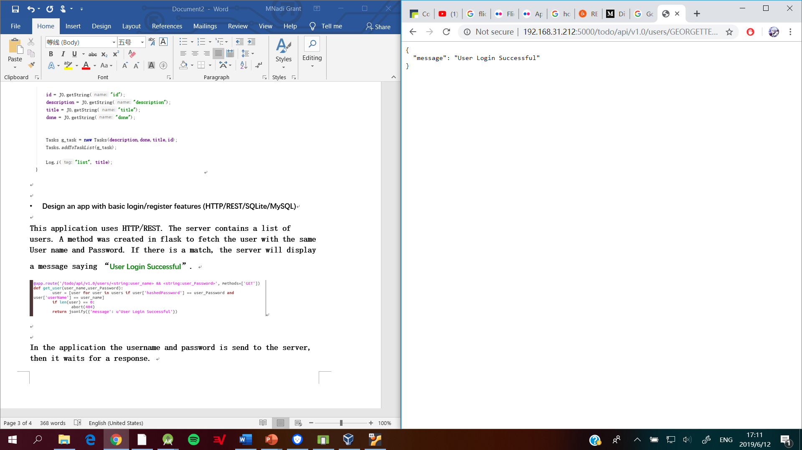

In the application the username and password is send to the server, then it waits for a response.

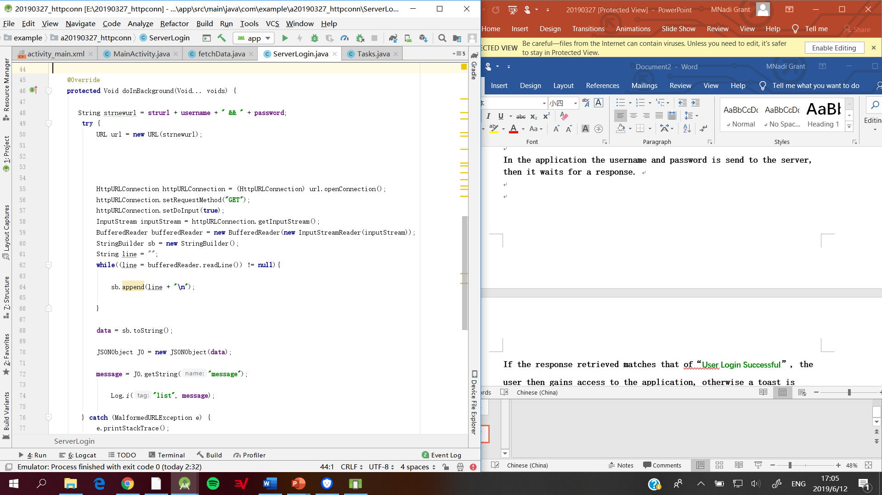

If the response retrieved matches that of “User Login Successful”, the user then gains access to the application, otherwise a toast is shown that says “Login Failed”.

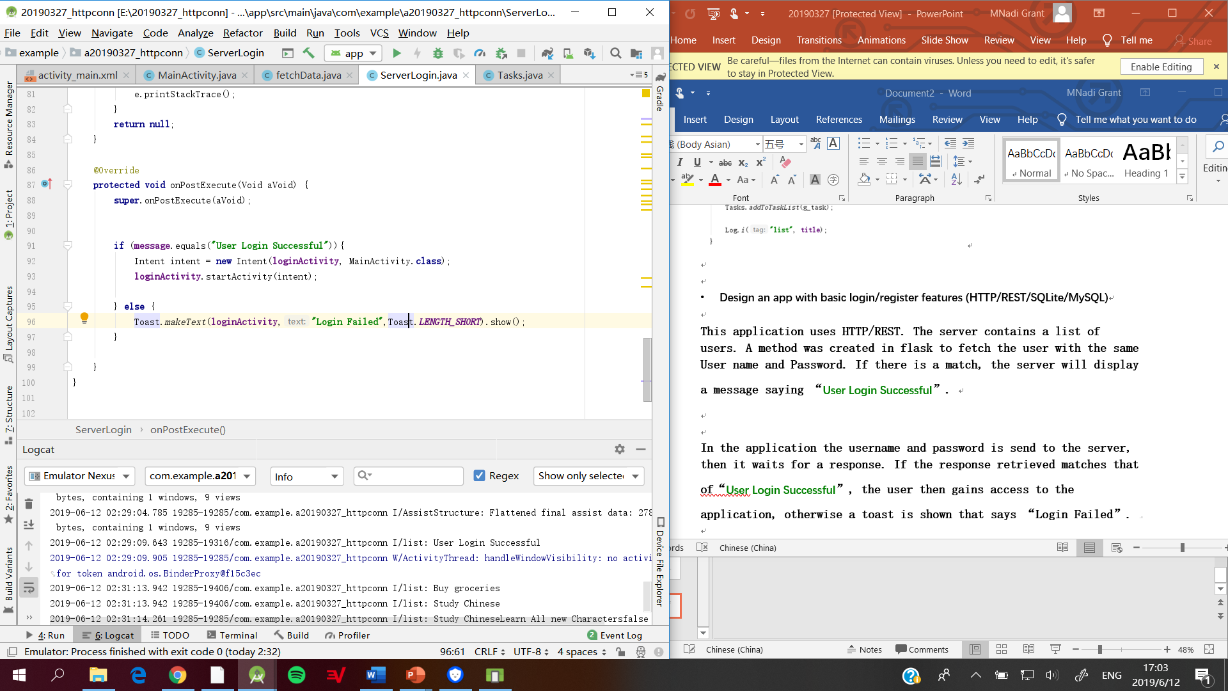

* **Think about Gson, which maps JSON data to Java objects automatically**

Gson is a Java library that can be used to convert Java Objects into their JSON representation. It contains toJson() and fromJson() methods that is use to convert Java objects to JSON and vice-versa. An example of this is done in the next exercise.